Pay Transaction (01)

This prototype shows what the page would look like when a user tries to make a transaction.

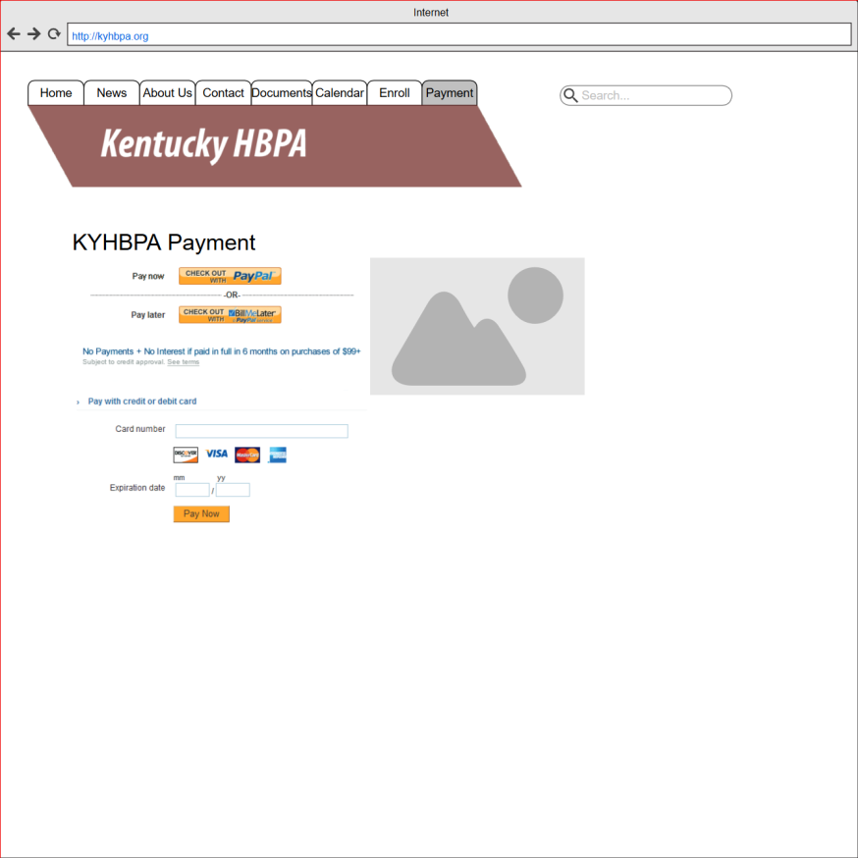

Submit membership information (02)

This prototype shows what the user might see when they try to submit membership information.

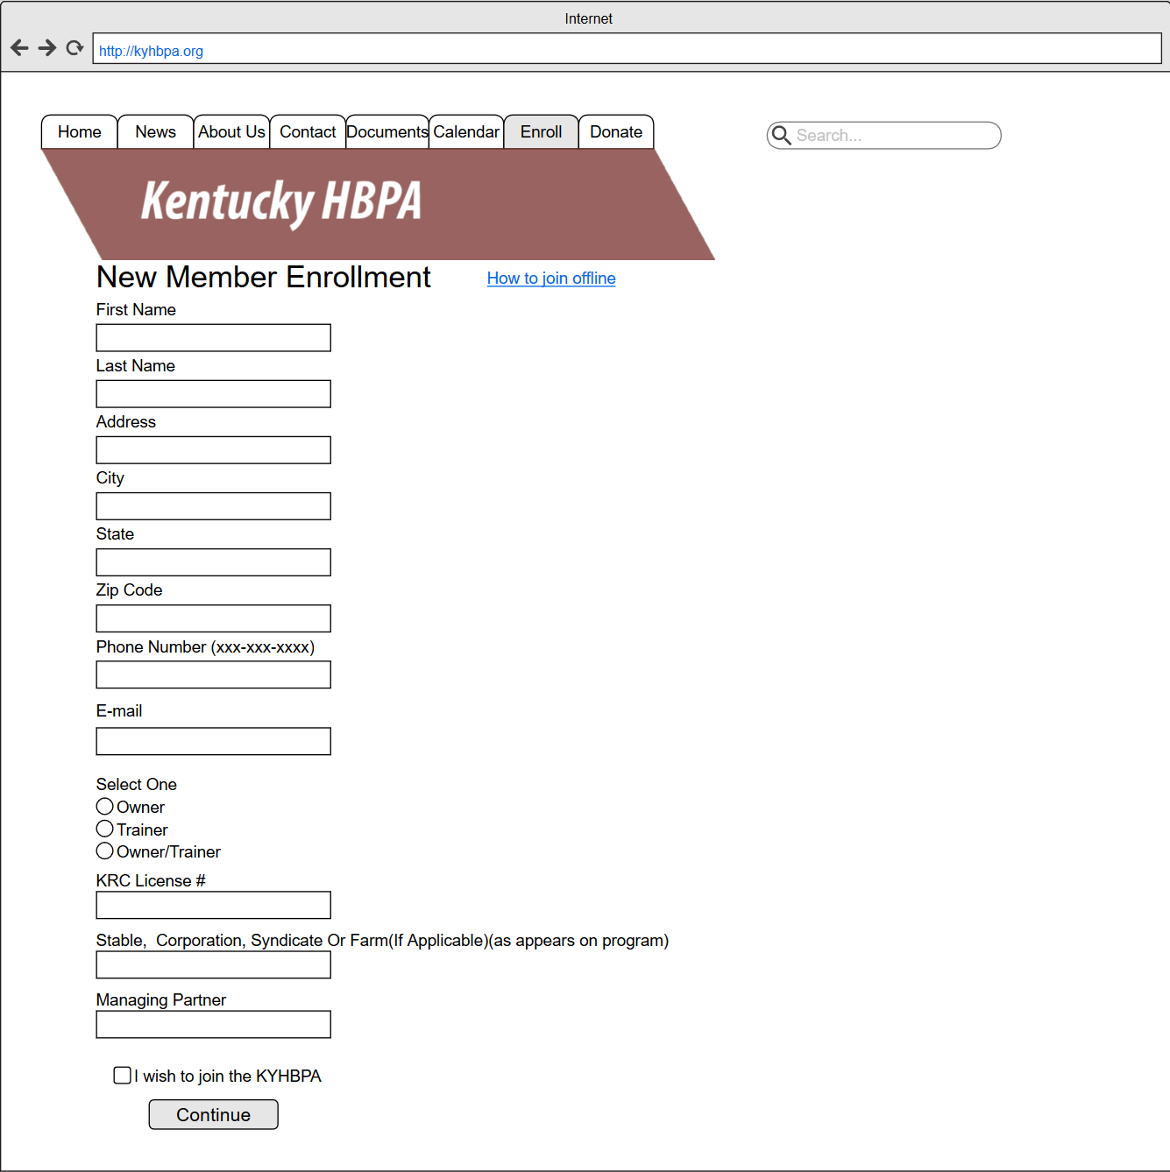

Social Media Links (03)

This page contains links at the bottom that the user can click on to access the KHBPA’s social media accounts.

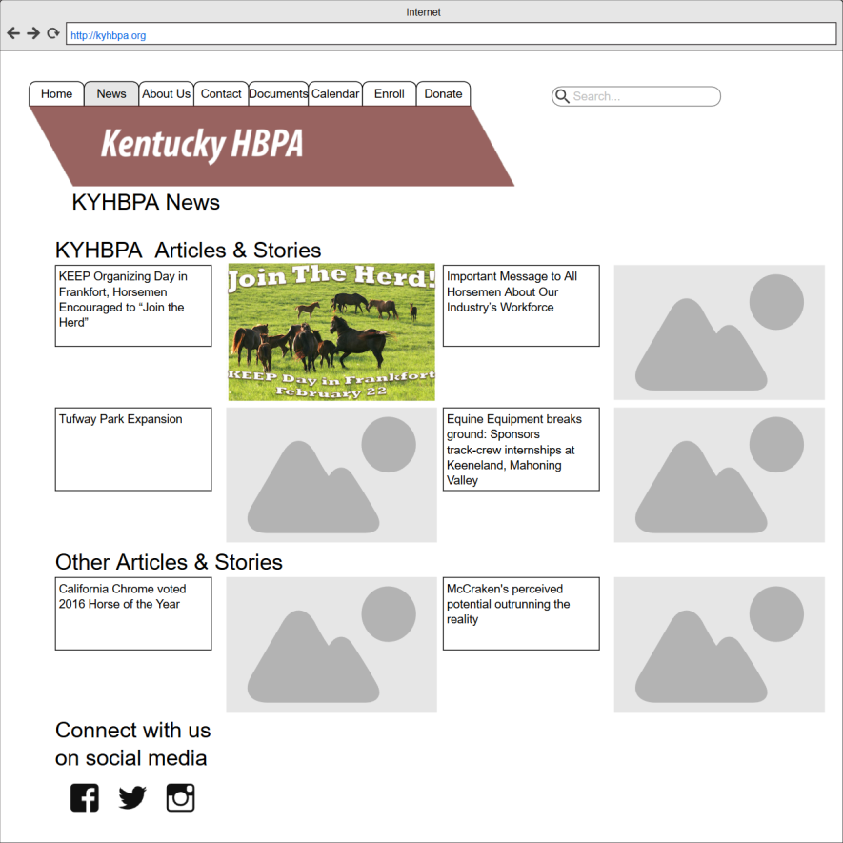

Submit Digital Signature (04)

This prototype shows an example of how users can digitally sign forms.

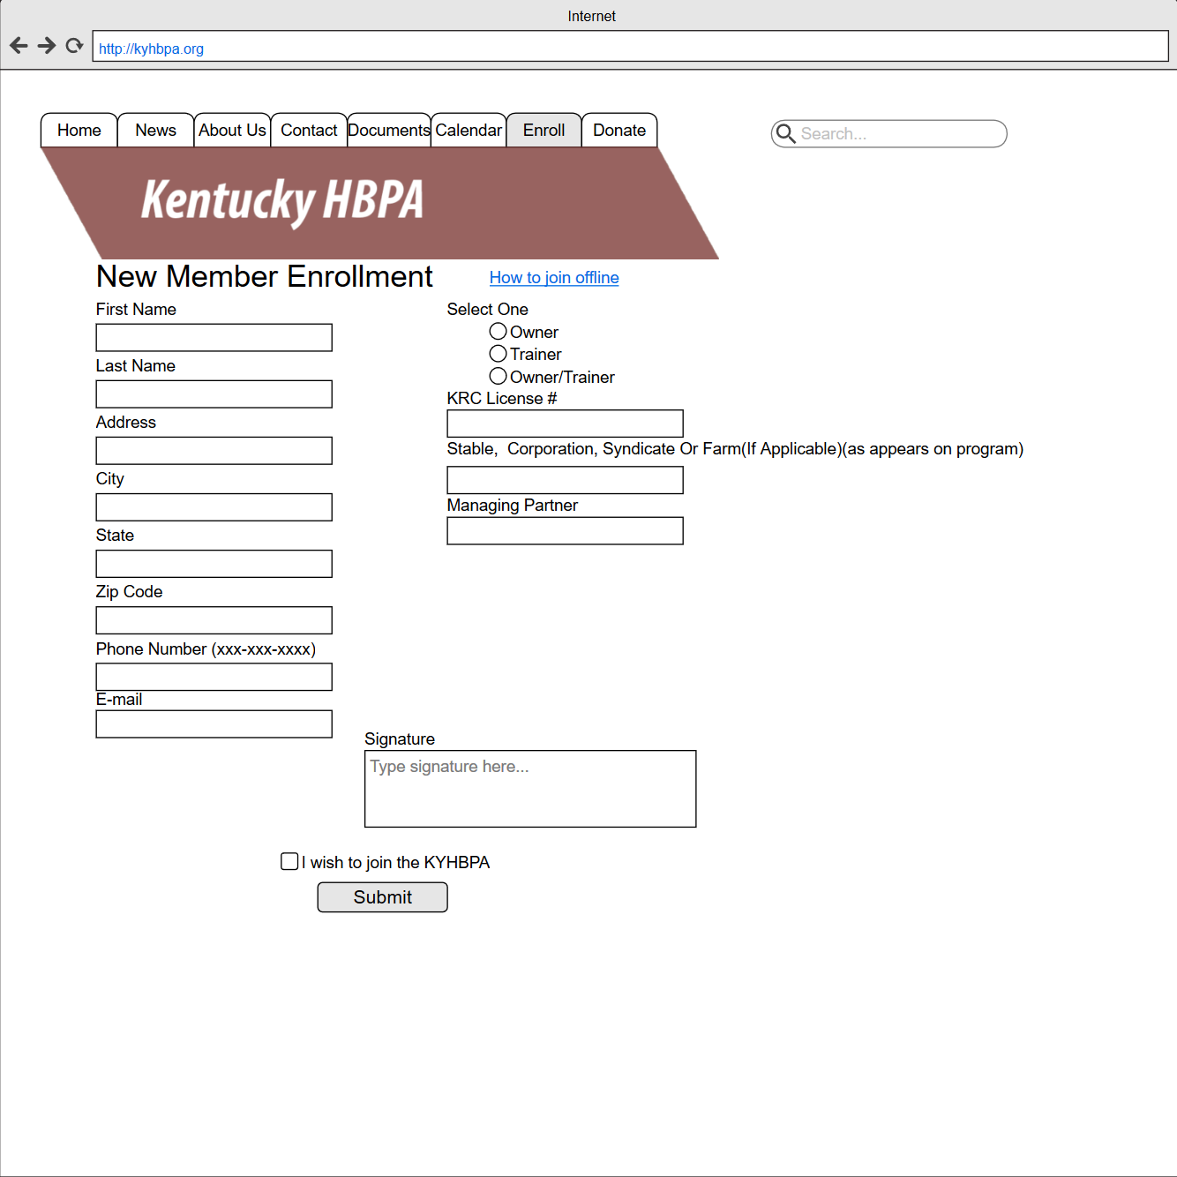

Online Donation (05)

This prototype shows the initial screen users see when they make a donation.

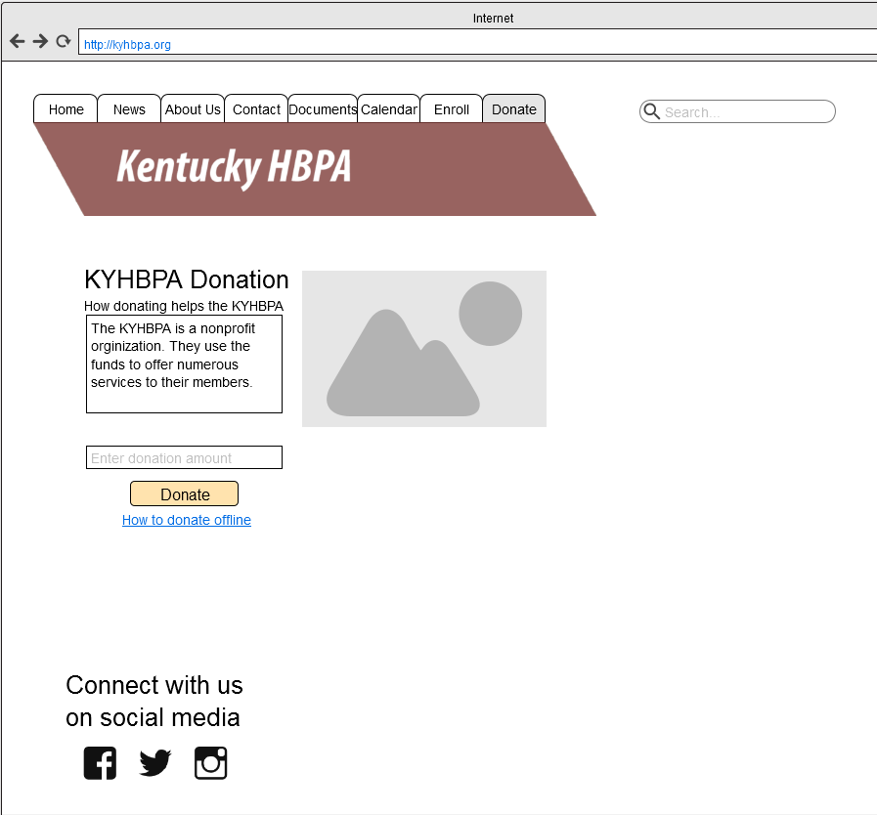

Partner Organizations (06)

This prototype shows what users see when they visit the page about partner organizations.

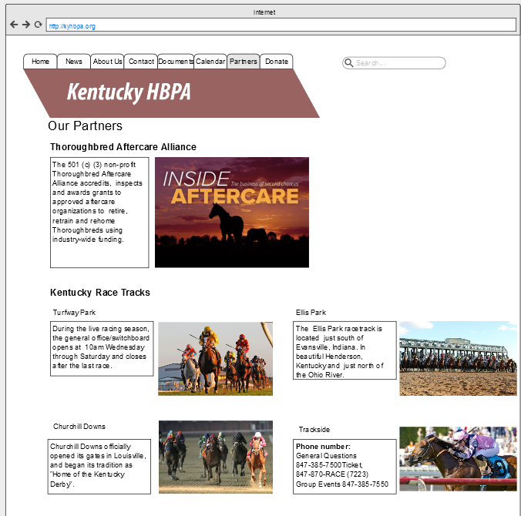

About Us (07)

This prototype shows the “about us” page.

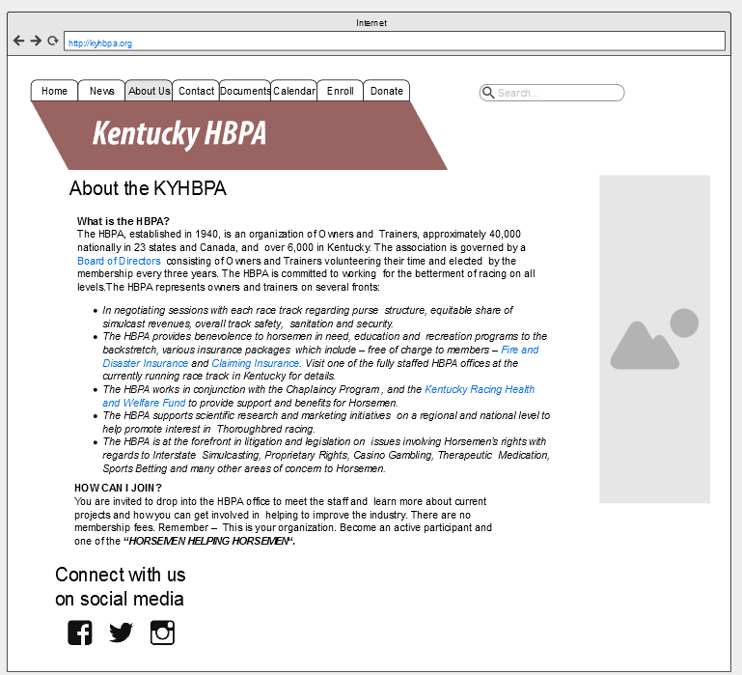

Polling (08)

This prototype shows what users see when they poll.

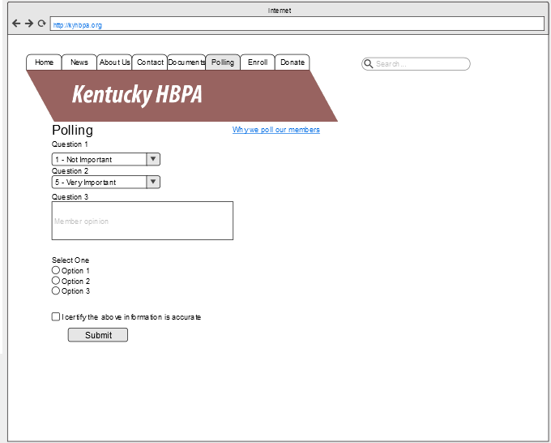

News Page (09)

This prototype shows an example of the news page home page.

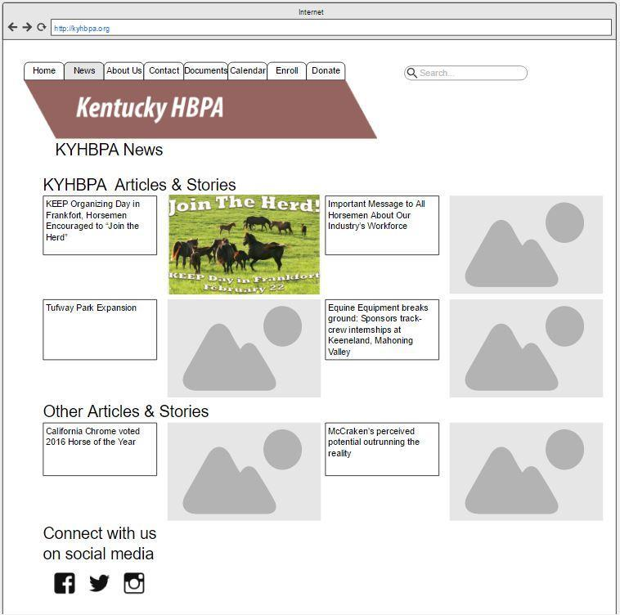

Archiving News (10)

This prototype shows what the archived news page might look like.

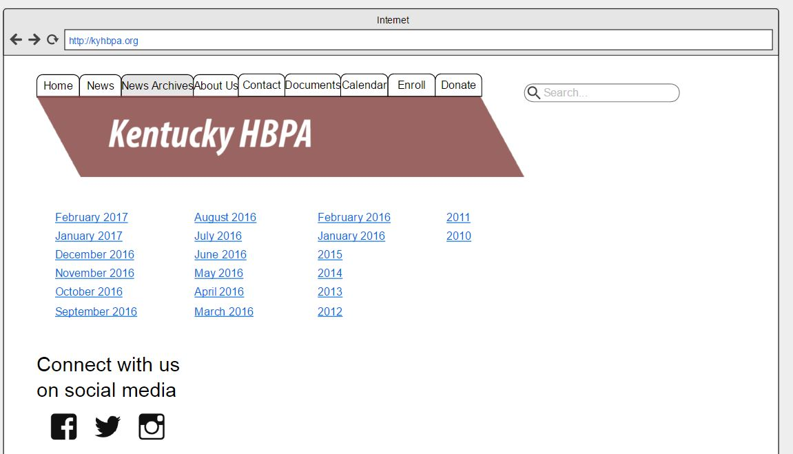

Contact Page (11)

This prototype shows what the contact page might look like.

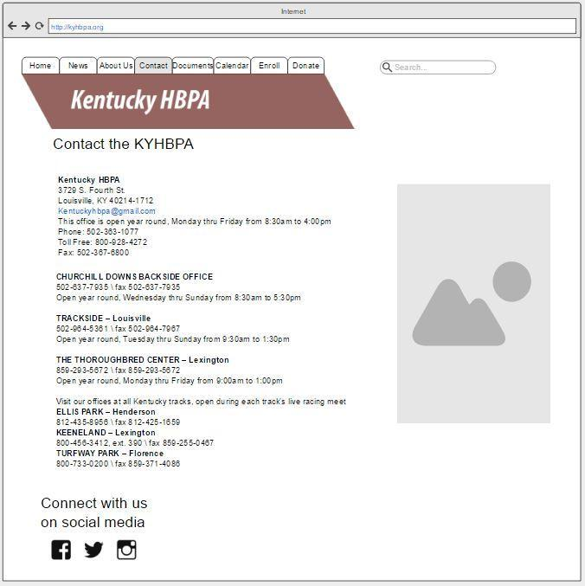

Documents (12)

This prototype shows what the page looks like when users try to upload documents.

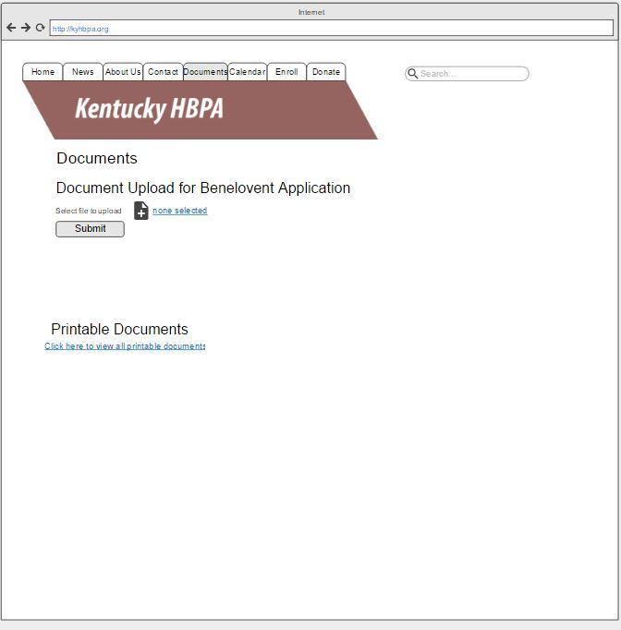

Calendar (13)

Legislation (14)

This prototype shows what users would see when they look at the legislation page.

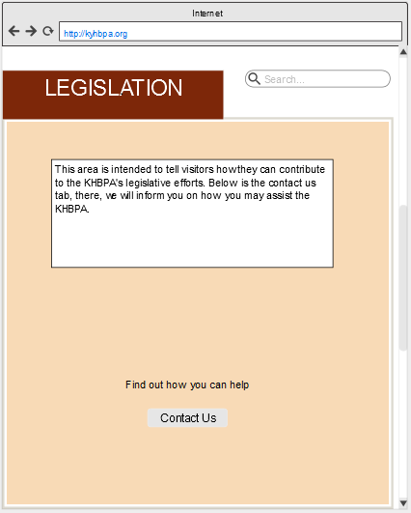

FAQ (15)

This prototype shows what users would see when they want to ask questions.

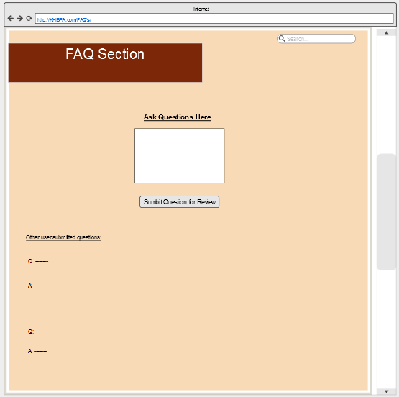

Racing Education (16)

This prototype shows what users might see when they enter the racing education page.

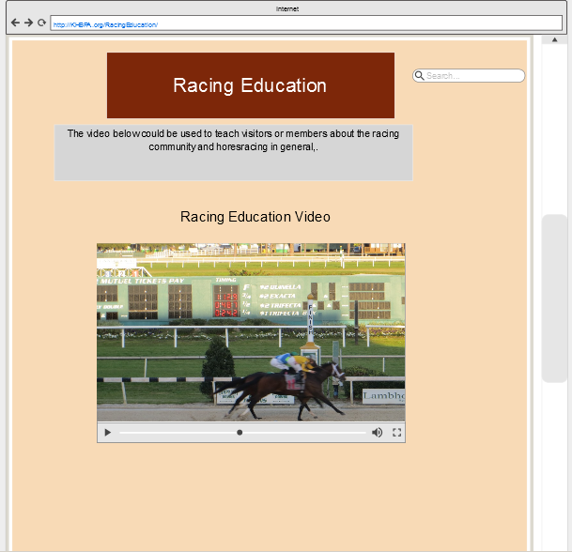

Trainers (17)

This prototype shows what users might see when they enter the trainers page.

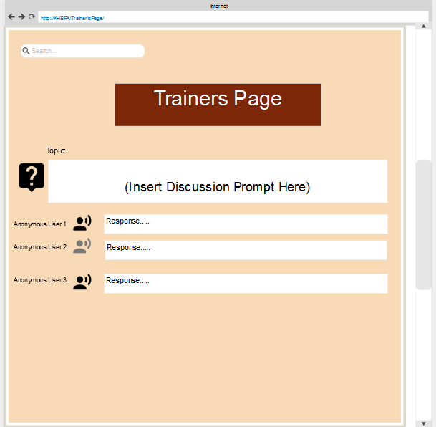

Photo Gallery (18)

This prototype shows what users might see when they enter the photo gallery.

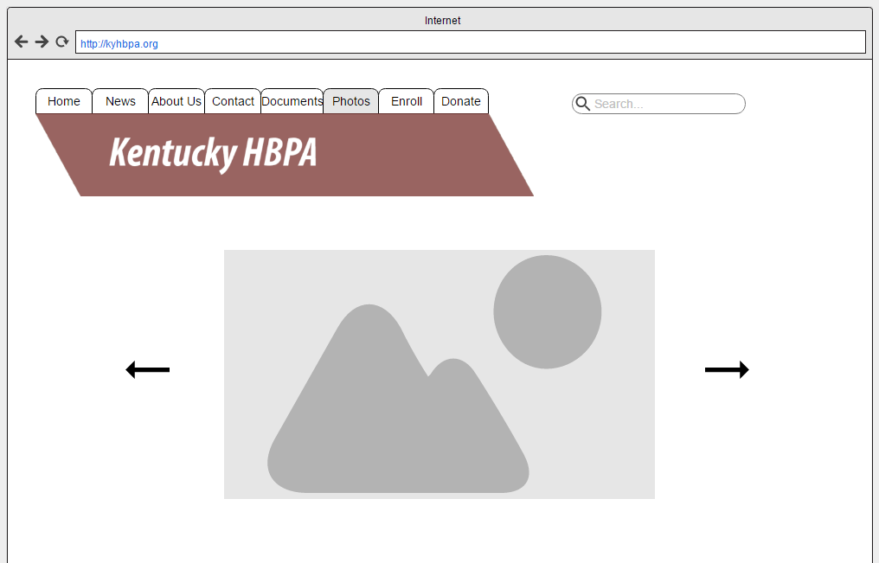

Track Info (19)

This prototype shows what users might see on the Track Information page.

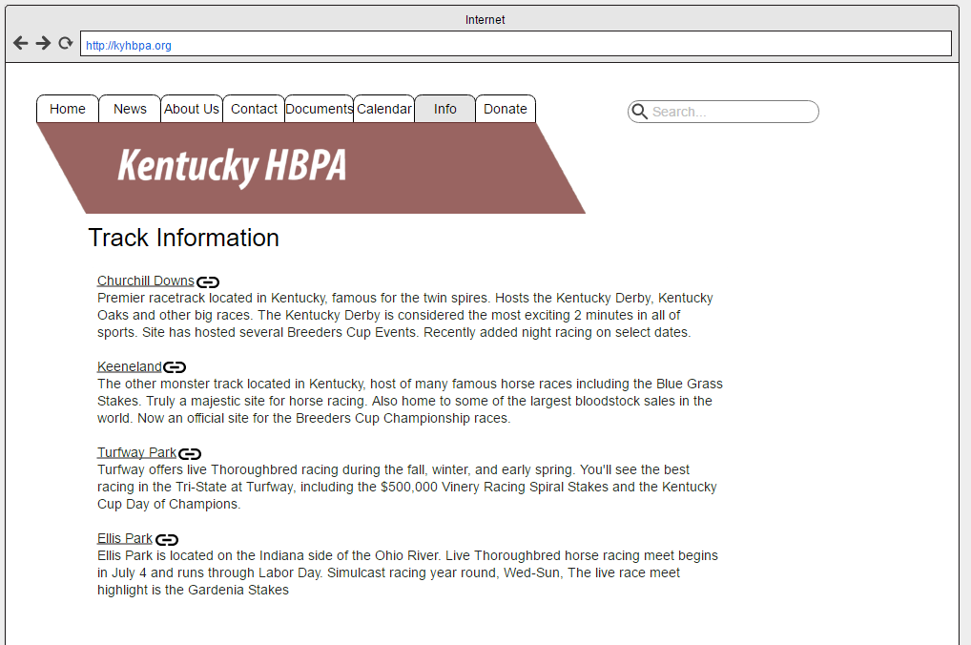

HBPA Chapters (20)

This prototype shows what users might see when they enter the Other State Chapter Information page.

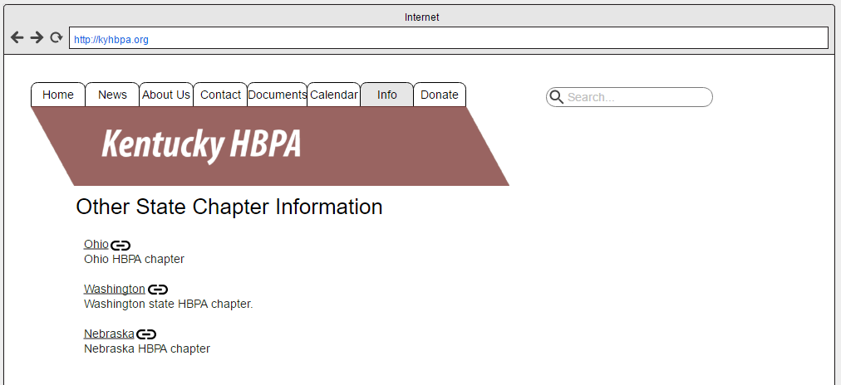

Info Request (21)

This prototype shows what users might see when they request information.

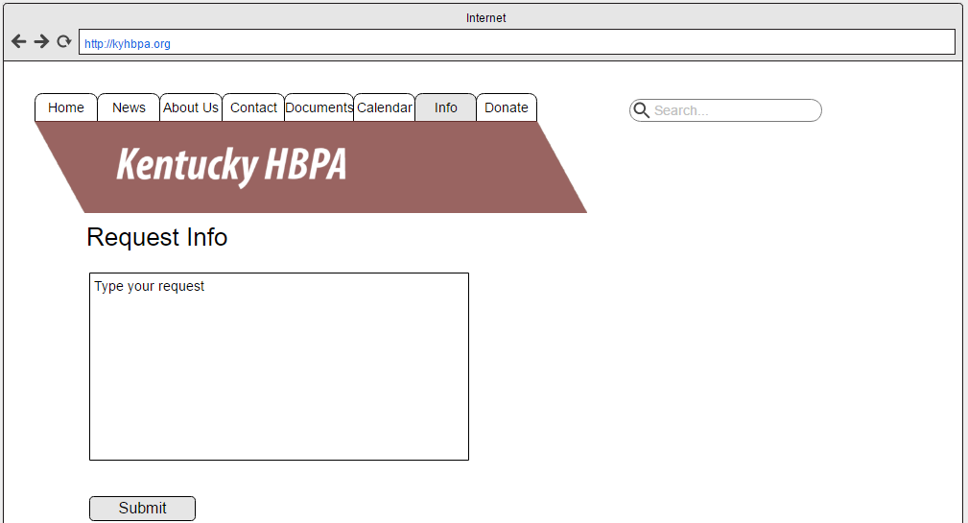

Subscribe to Newsletter (22)

This prototype shows what users might see when they subscribe to the newsletter.

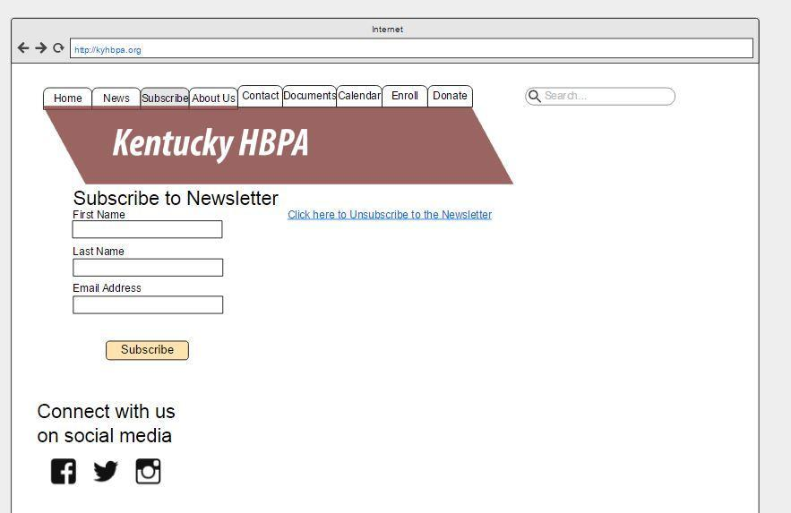

Access News Archives (23)

This prototype shows what users would see when accessing news archives.

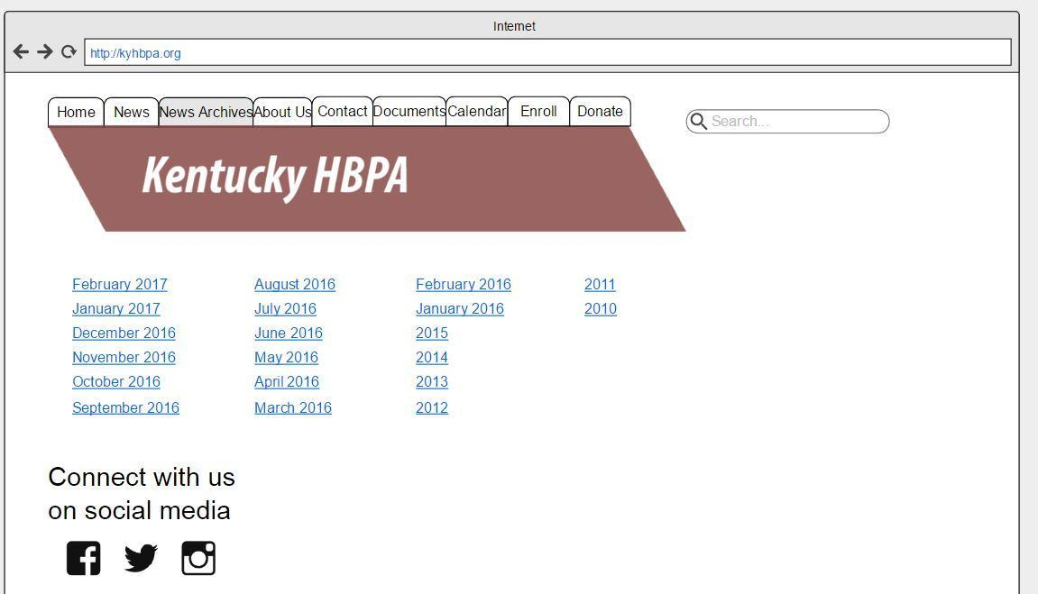

Access News Archives (23)

This prototype shows what users would see when accessing a specific month of news archives.

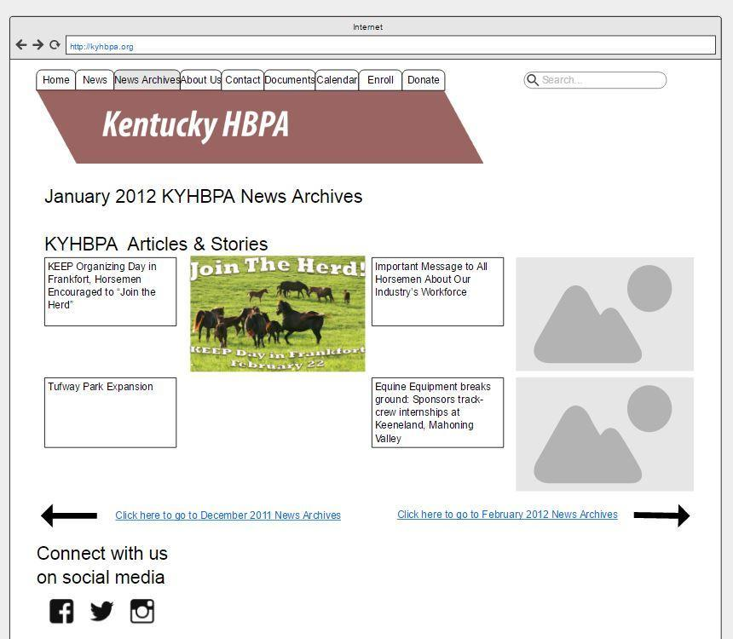

Post Photo (24)

This prototype shows what users would see when they attempt to post photos.

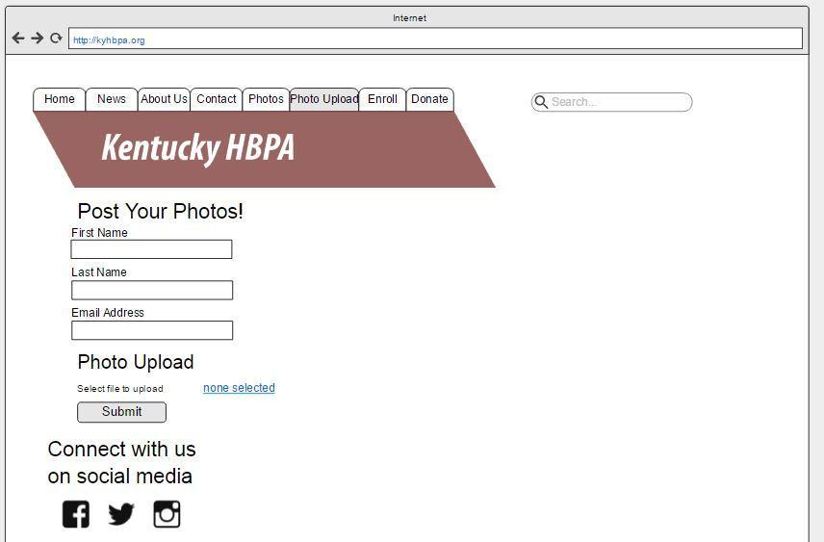

Access Blog (25)

This prototype shows what users might see when they try to access Jennie Rees’ blog.

